Sea Scallops Salad (Jeannine)
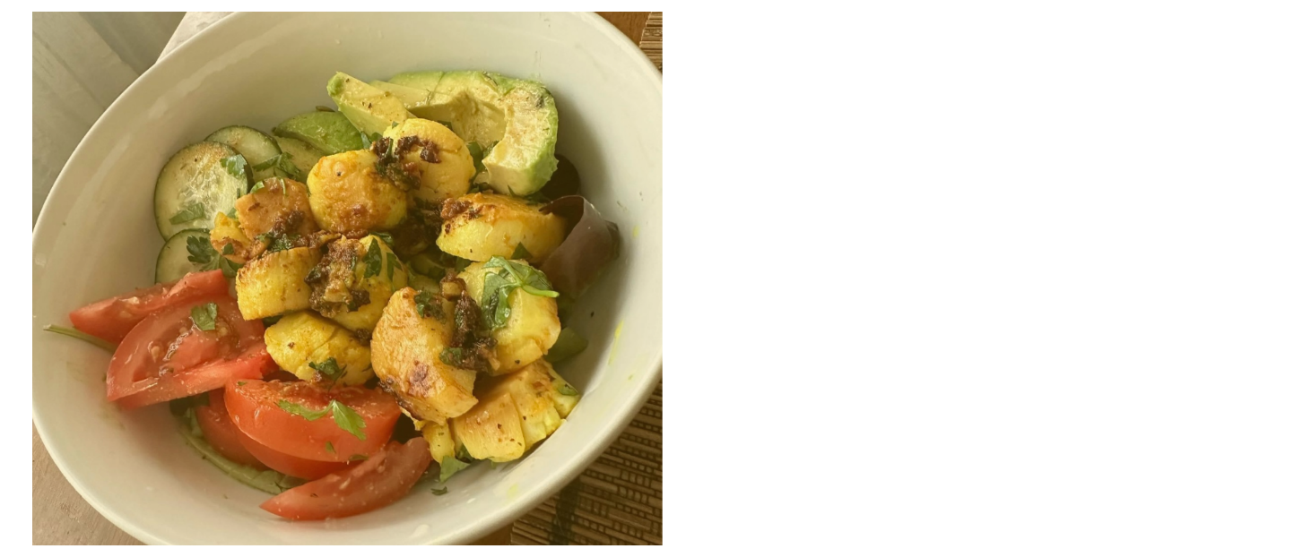 (I just made it up on the spot!)
Ingredients:
Sea Scallops
Butter
Olive Oil
Garlic
Turmeric
Ginger
Cilantro
Cucumbers
Avocados
Tomatoes
Instructions:
Grate Ginger & Turmeric on Sea Scallops along with Olive Oil
Put butter and garlic in a pan
Add the scallops and cook until browned on both sides
Place on top of Cucumber, Avocado & Tomato salad
Sprinkle Cilantro on top
Scrumptious!

